**Directions:**

1. **Looking at your keyboard copy the letters to the correct key**
2. **Color the hands as follow: LEFT HAND (pinky=red; ring finger=green; middle finger= blue; pointer finger=yellow) RIGHT HAND (thumb=light blue; pointer finger=orange; middle finger=purple; ring finger=pink; pinky finger=brown)**
3. **Find the letters on the fingers and color those letters on the keyboard (ex: A is on the right pinky which is red)**

-

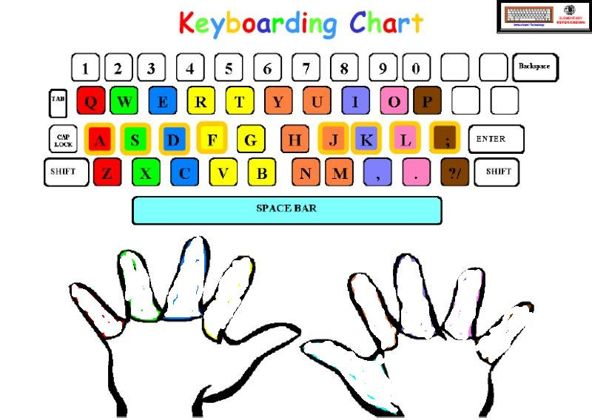

**1**

**2**

**4**

**3**

**5**

**6**

**8**

**7**

**9**

**0**

**backspace**

**;**

**Enter**

**,**

**.**

**?/**

**Shift**

**Spacebar**