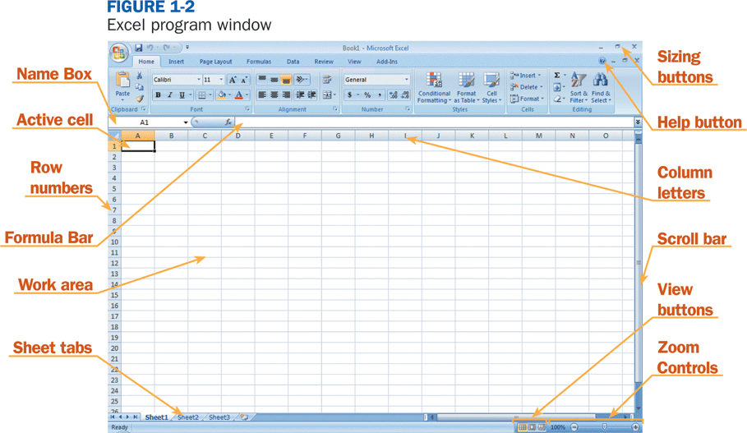

**NAME:____________________________**

***Directions:*** *Using the word bank provided, label the parts of this excel spreadsheet.*

**7**

**8**

**9**

**10**

**11**

**12**

**1**

**2**

**3**

**4**

**5**

**6**